Design Document

Line Item(s)
Line Item(s) | Release(s)

Document Information
Document Author:
Owning Component:
Responsible Manager:
Technical Contact:
Total Pages:

TABLE OF CONTENTS
Design Document 1
Line Item(s) 1
Document Information 1
1.0 Introduction 4
1.1 Overview 4
1.2 Applicability 4
1.3 Benefits 4
2.0 Functional Description and Usage 5
2.1 Functional Description 5
2.2 Use Cases 5
3.0 Programming Model:Reference 6
3.1 Graphical User Interface (GUI) 6
3.2 Command Line Interfaces (CLIs) 6
3.3 Application Programming Interfaces (APIs) 6
3.4 Events, Notifications and Exceptions 6
3.5 Configuration Attributes 6
4.0 PROGRAMMING MODEL: USAGE 7
4.1 Application Design Considerations 7
4.2 Programming Examples 7
4.3 Health and Recovery 7
4.4 Other Programming Details 7
4.5 Platform Considerations for Externals 7
5.0 DESIGN REQUIREMENTS 8
5.1 Design Principles 8
6.0 SYSTEM DESIGN 9
6.1 Primary Components 9
6.2 Component Interactions 9
6.3 Configuration 10
6.4 Performance Assessment 10
6.5 Internationalization 10
6.6 Development Tools 10
6.7 Testing 11
6.8 Release-to-Release Compatibility 11
6.9 Extensibility 11
6.10 Platform Considerations 11
6.11 Accessibility Considerations 11
6.12 Additional Design Elements 12
7.0 SUPPORTING RATIONALE 13
7.1 Design Alternatives 13
7.2 Commercialization 13
7.3 Inter-Dependencies 13
7.4 Standards and Industry Trends 13
8.0 ISSUES 13
9.0 FUTURE ENHANCEMENTS 13

Introduction
Describe the functional characteristics of the component and interactions between this and other components.

This online game, “IM FARMER”, provides a virtual farming system and gives players a interesting environment to run their own farm. Players can perform all kinds of agricultural activities within this farming system. The internet society relationship also be manipulated into the game and there will be some interactions between players of the society.

Overview
Decompose the description of the component into its major, externally visible parts. Focus on the major relationships between the parts as visible to the end-user. (how is this component seen by the end user?)

“IM FAMER” will be designed as user interactive game. Player will need to register as a network society member and login when they want to play the game. There will be a virtual farm own by each player. Within this farm, player can work on cultivate their land and raise their livestock. A market system will be provided by the game system for players to purchase what they need or sell what they have. This market system will be presented as a popup window and list all merchandise and their prices. Players can see the farm of other players’. On other players’ farm, players will be able to watering, debugging or even stealing the product of other players’ farm.

Applicability
Identify the platforms and editions to which this system design applies.

This game is made by flash technology and will run on web browser of any OS. Supported browsers are list following:
- Internet Explorer 6.0 or above
- Firefox 2.0 or above
- Safari 4.0 or above
- Chrome 3 or above

Benefits
Explain the key benefits of this component to the end user. (why is this component important?)

This game will bring player an entertaining and interesting farming system. Players will learn some agricultural knowledge and training their patient with the game. Extending relationship by interacting with another player of the network society is also another major benefit of this game.

Functional Description and Usage

Functional Description
Describe the functional characteristics of the component. This should highlight the areas of functionality within the component that require specific design consideration.
The result should be that you have laid the foundation on which the rest of the system descriptions can be understood. (what is this component?)

This game builds up a virtual farming environment and combines with network society interactions. The whole system of this game will be event notification system. Components within this system will notify events and events will be handled by those components that care about this event. For example, when the fruit is mature and ready for harvest, there will be an event send out and the Virtual Farm will handle this event and update the status. …

Use Cases
Use cases answer the question, “What are the different ways that customers will use this function?” A use case includes a description, a user goal (why is it performed?), the role who performs it, preconditions, results of performing it, a task flow and any error flows.

Use Case 1: user purchase seed from market
user goal: increase the seed inventory
role: player, market component, virtual farm component
precondition: player has login to the game system and open market popup window
result: the seed inventory status is increased according to the amount of purchase
task flow:
1. user choose the item(s) and specify the amount
2. user press submit
3. market system check the credit of the user
4. if the credit is greater or equal than the total purchase amount, then decrease the user credit and add item(s) purchased into user inventory
error flow
- if user credit is less the purchase amount, popup a warning dialog.
- if user idol too long and cause system session expire, fire a internal event to cancel all transaction
- …

Use Case 2: player1 steal the fruit from the player2’s farm
user goal: increase the fruit inventory
role: player1, player2’s virtual farm component
precondition: player1 has login to the game system and open browsing player2’s farm. The fruit at player2’s farm is mature.
result: the inventory status of player1 is increased according to the amount of stealing. The farm status of player2 is updated according to the amount of stealing by player1.
task flow:
1. player1 choose the fruit to steal and steal
2. the amount of the mature fruit at player2’s farm decrease by 1
3. the player2’s farm update status
4. the player1’s farm update status
error flow
- if the amount of mature fruit is less than 1, the stealing will not succeed.
…

Use Case 3: system notify the fruit is mature
user goal: change the player’s farm status
role: internal notification system
precondition: the time set for fruit at player’s farm is up
result: the status of the fruit is mature and the amount of mature fruit will be specified
task flow:
1. internal event is fired to player’s farm
2. system generate a random number as the amount of fruit that is mature
3. update farm status
4. update GUI presenting pictures
error flow
…

Programming Model: Reference

Graphical User Interface (GUI)
Include any external user interfaces that will be introduced by your component. Include the screen shots and brief description for each.

Command Line Interfaces (CLIs)
List and describe any command line interfaces that accompany this component

Application Programming Interfaces (APIs)
Provide UML diagrams and a brief description for each of the interfaces and significant types for the previously identified elements of the component.

Events, Notifications and Exceptions
Specify what events or notifications are consumed or produced by your component that Customers should be aware of. Also, describe how exceptions to the normal processing flow that will affect external users are handled by your component.

Configuration Attributes
List any configuration attributes that will be presented to the administration, either through the admin console for your component. Identify the configuration attribute name, fully-specified range of valid values, default value and consequences for each attribute

PROGRAMMING MODEL: USAGE

Application Design Considerations
Explain anything else that you think the application developer that will use your component should consider.

Programming Examples
Provide coding samples that demonstrate the use of the component’s primary functions.

Health and Recovery
Describe what the administrator should do to keep your component healthy. Describe how an administrator will recover your component should it fail — what logs should they clear out, what state should the reset, etc.

Other Programming Details
Describe any special considerations or constraints for your programming interfaces — especially, things that you can’t do with your interface or where it can’t be used.

Platform Considerations for Externals
Describe the platform considerations. This is called out explicitly to trigger more focused thoughts to address architectural differences caused by different OS platforms.

DESIGN REQUIREMENTS
Elaborate on any significant design requirements that pertain uniquely to the component. Most of these should be derived from the preceding usage scenarios.

Design Principles
The following represents a set of design principles that pertain to this component. In general it is good to establish the design principles that will govern all the components of a system. You may be able to adapt these principles to your own system

Since the internal event will be an important communication method within the game, every component need to adopt observer design pattern. …

SYSTEM DESIGN

Primary Components
List and describe the primary elements of the component. For the most part, these will be represented by identifiable object classes, but may also be representative of utilities, user interfaces, devices, resources, or general (non-object) programs

Virtual Farm Component: this component will store the status of virtual farm, update the status of the farm and provide information to incoming inquiry from other players. This component contains sub-components of plants, animals, land and decoration.

Graphic User Interface Component: The component will be in charge of receiving user’s input and current status presentation.

Timing/Notification Component: Reporting timing and notify event within the whole game system. Since the time is an important factor in the game, this component
Market System Component: …
Query Component:…

Component Interactions
Include analysis, inheritance, entity-relationship, data model, and flow diagrams as well as descriptions of important framework and exception conditions

Object Model and Relationships
Object model diagrams that help understand the classes introduced by this component. Focus primarily on interface definitions, operations, attributes and interface inheritance
Structure Diagrams
Class Diagram/Component Diagram/Composite structure diagram etc…
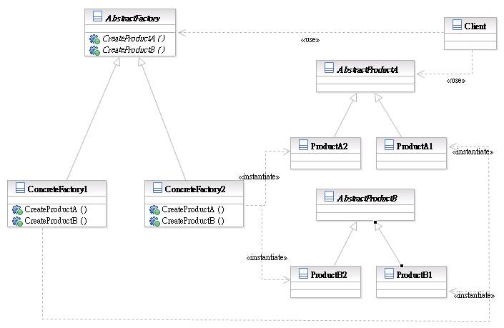

Flows
Object interaction diagrams that show the flow of control and state between objects in the system design of this component. This can also show state-transition diagrams as needed to better understand the flow of control and state
Behavior Diagrams/Interaction Diagrams
Activity diagram /sequence diagram etc…
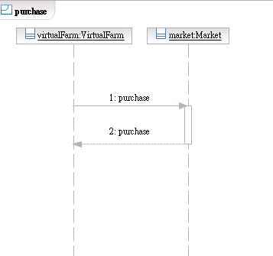

Exception Handling
Draw out any relevant information about how exception to the standard and expected logic is handled within the design. This is not meant to focus strictly on what language or distributed object exceptions are raised by any particular method within the component, but rather is intended to focus on how when exceptions to the main logic-paths do occur how they are handled.

Configuration
Describe how to initialize and manage the configuration of the system. For example, if the system uses xml-based configuration file, then describe how to modify the attributes in the file to bring system up and running.

Performance Assessment
What is the performance impact of this design on industry benchmarks? Note this in terms of the percentage change that you anticipate to the benchmark throughput.

Internationalization
Describe how this component will be enabled to support its use in other countries and in other languages and customs

Development Tools
Identify any development tool requirements that relate to the component. Include, for instance, tool pallets for visual builder tools, class libraries, etc. that may be needed to develop applications that exploit the component

Testing
Describe any conditions or environments that you think should be verified as part of a system test of this design. What kinds of situations would stress this design? What happens when features of the design are overloaded and what conditions might cause such an overload? How should the system behave in the event that critical servers, databases, or communication paths that this design depends upon are disrupted? Are there simple operational mistakes or tuning errors that may cause the design to behave poorly? Can the operations staff make dynamic tuning adjustments or other system changes that affect the behavior of this design? Do the features introduced in this design preclude simple migration of existing applications from previous versions of the product?

Release-to-Release Compatibility
Identify whether this design will affect portability or interoperation of applications hosted in a different version. If you break portability or interoperation you better have a very good reason for it. The general rule is interfaces can be deprecated, but must continue to be supported for three years after the interface has been marked as deprecated. Otherwise, we must maintain backwards compatibility.

Extensibility
Describe any extensibility features of this design. This should support any description you’ve provided for extensibility in the Programming Model

Platform Considerations
Describe the platform considerations, concerns and/or issues in the subsections below as they apply to internals and system design

Accessibility Considerations
Make offerings accessible to people who have disabilities.

Additional Design Elements
Include each additional design element that needs to be considered within this component. This section exists to cover anything that can not be covered in the sections that represent “common and standard” design elements of all components. They are aggregated under this sub-section only to provide some consistent structure to the overall design chapter.

SUPPORTING RATIONALE

Design Alternatives
Identify any design alternatives that were considered for the component and that may be relevant in future implementations of the component

Commercialization
Describe how and what commercial system facilities are used within the implementation of the component for delivering component function

Inter-Dependencies
Enumerate all technical and critical-path dependencies the component has on other components

Standards and Industry Trends
Identify which standards pertain to the component; and, where the component extends, deviates from, or integrates with the standard.

ISSUES
List any known issues that the design does not resolve or that have a bearing on future implementations of the component. This can also be used as a place holder for additional things that need to be factored in to the design, prior to that actually have been performed.

FUTURE ENHANCEMENTS
Describe any enhancements that should be considered in the future, but for which may have a bearing on the current design

