Design Document

Line Item(s)
Line Item(s) | Release(s)

Document Information
Document Author:
Owning Component:
Responsible Manager:
Technical Contact:
Total Pages:

TABLE OF CONTENTS
Design Document 1
Line Item(s) 1
Document Information 1
1.0 Introduction 4
1.1 Overview 4
1.2 Applicability 4
1.3 Benefits 4
2.0 Functional Description and Usage 5
2.1 Functional Description 5
2.2 Use Cases 5
3.0 Programming Model:Reference 6
3.1 Graphical User Interface (GUI) 6
3.2 Command Line Interfaces (CLIs) 6
3.3 Application Programming Interfaces (APIs) 6
3.4 Events, Notifications and Exceptions 6
3.5 Configuration Attributes 6
4.0 PROGRAMMING MODEL: USAGE 7
4.1 Application Design Considerations 7
4.2 Programming Examples 7
4.3 Health and Recovery 7
4.4 Other Programming Details 7
4.5 Platform Considerations for Externals 7
5.0 DESIGN REQUIREMENTS 8
5.1 Design Principles 8
6.0 SYSTEM DESIGN 9
6.1 Primary Components 9
6.2 Component Interactions 9
6.3 Configuration 10
6.4 Performance Assessment 10
6.5 Internationalization 10
6.6 Development Tools 10
6.7 Testing 11
6.8 Release-to-Release Compatibility 11
6.9 Extensibility 11
6.10 Platform Considerations 11
6.11 Accessibility Considerations 11
6.12 Additional Design Elements 12
7.0 SUPPORTING RATIONALE 13
7.1 Design Alternatives 13
7.2 Commercialization 13
7.3 Inter-Dependencies 13
7.4 Standards and Industry Trends 13
8.0 ISSUES 13
9.0 FUTURE ENHANCEMENTS 13

Introduction
Describe the functional characteristics of the component and interactions between this and other components.

This hospital registration system provides the web services for remote client to request. This registration system will expose its web services on the internet and then remote clients can access those web services via internet. The remote client could be either mobile devices or any computer that has the ability to request the web services in the internet.

Overview
Decompose the description of the component into its major, externally visible parts. Focus on the major relationships between the parts as visible to the end-user. (how is this component seen by the end user?)

This registration system will provide its service as web services. It will can take the requests from remote client. The end users will use the client application on his/her computer or mobile device to get the services he/she want.

Applicability
Identify the platforms and editions to which this system design applies.

This server application will be developed and run on Linux
- RedHat 6.0 or higher

Benefits
Explain the key benefits of this component to the end user. (why is this component important?)

Web service is a widely used web technology in Web2.0. Converting the registration system into RESTful web service will make it easier to be adapted by remote client, especially for mobile device applications. Thus, combined with the client application in mobile devices, the registration services will be more easily accessed by end user like patients, doctors, or even system administrators

Functional Description and Usage

Functional Description
Describe the functional characteristics of the component. This should highlight the areas of functionality within the component that require specific design consideration.
The result should be that you have laid the foundation on which the rest of the system descriptions can be understood. (what is this component?)

This registration system contains three two parts
1) Request handling component: this component will handle the incoming web service requests, extract the parameter value and perform the request. If retrieving or modifying DataBase is needed, then it will send out the modification request to DataBase action component.
2) DataBase action component: this component will handle the DataBase modification request and do the medication to the DataBase.

Use Cases
Use cases answer the question, “What are the different ways that customers will use this function?” A use case includes a description, a user goal (why is it performed?), the role who performs it, preconditions, results of performing it, a task flow and any error flows.

Use Case 1: user login
user goal: login to the registration system
role: Request Handling component, DataBase action component, Backend DataBase
precondition: user have an account in remote registration system
result: user successfully login and application has the user session
task flow:
1. received user login request
2. extract user name/password
3. query user name and password data via DataBase action component
4. Authenticate the user and respond the login request
error flow
- if user enter wrong password
- if connection broken during communication with remote registration system
- …

Use Case 2: Patient register
user goal: Patient register to a doctor on some date
role: Request handling component, DataBase action component, Backend DataBase
precondition: Patient already login.
result: Patient successfully register to a doctor on the date he/she want.
task flow:
1. Received registration request
2. Extract the doctor name, date and time from the request
3. Query the doctor registration schedule via DataBase action component
4. Modify doctor registration status in DataBase
5. Return the registration number to the client
error flow
- it the date is not available
…

Programming Model: Reference

Graphical User Interface (GUI)
Include any external user interfaces that will be introduced by your component. Include the screen shots and brief description for each.

Command Line Interfaces (CLIs)
List and describe any command line interfaces that accompany this component

Application Programming Interfaces (APIs)
Provide UML diagrams and a brief description for each of the interfaces and significant types for the previously identified elements of the component.
Login
GET system/authenticate
Description: Allow a user to login the hospital registration system
Resource URL: https://hostipal.ntu.com/system/authenticate
Parameters:
login_name (required) the login name of user
Example values: patientA
login_password (required) the login password
force_login (optional) force user to provide a credentials
Example Request
https://hostipal.ntu.com/system/authenticate/abc.json

GET system/authorize
Registration

More examples
https://dev.twitter.com/docs/api/1.1
http://www.flickr.com/services/api/flickr.photos.search.thml
http://petstore.swagger.wordnik.com/

Events, Notifications and Exceptions
Specify what events or notifications are consumed or produced by your component that Customers should be aware of. Also, describe how exceptions to the normal processing flow that will affect external users are handled by your component.

Configuration Attributes
List any configuration attributes that will be presented to the administration, either through the admin console for your component. Identify the configuration attribute name, fully-specified range of valid values, default value and consequences for each attribute

PROGRAMMING MODEL: USAGE

Application Design Considerations
Explain anything else that you think the application developer that will use your component should consider.

Programming Examples
Provide coding samples that demonstrate the use of the component’s primary functions.

Health and Recovery
Describe what the administrator should do to keep your component healthy. Describe how an administrator will recover your component should it fail — what logs should they clear out, what state should the reset, etc.

Other Programming Details
Describe any special considerations or constraints for your programming interfaces — especially, things that you can’t do with your interface or where it can’t be used.

Platform Considerations for Externals
Describe the platform considerations. This is called out explicitly to trigger more focused thoughts to address architectural differences caused by different OS platforms.

DESIGN REQUIREMENTS
Elaborate on any significant design requirements that pertain uniquely to the component. Most of these should be derived from the preceding usage scenarios.

Design Principles
The following represents a set of design principles that pertain to this component. In general it is good to establish the design principles that will govern all the components of a system. You may be able to adapt these principles to your own system

SYSTEM DESIGN

Primary Components
List and describe the primary elements of the component. For the most part, these will be represented by identifiable object classes, but may also be representative of utilities, user interfaces, devices, resources, or general (non-object) programs

Component Interactions
Include analysis, inheritance, entity-relationship, data model, and flow diagrams as well as descriptions of important framework and exception conditions

Object Model and Relationships
Object model diagrams that help understand the classes introduced by this component. Focus primarily on interface definitions, operations, attributes and interface inheritance
Structure Diagrams
Class Diagram/Component Diagram/Composite structure diagram etc…
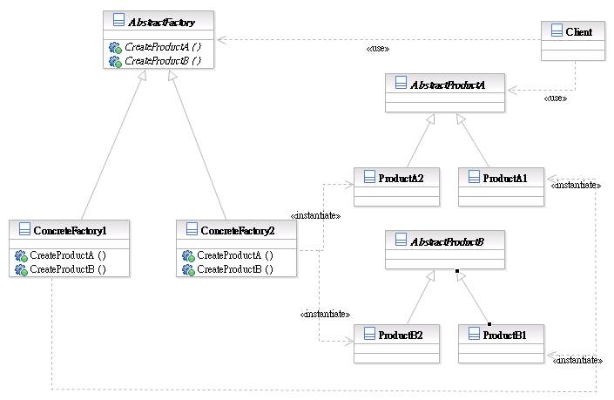

Flows
Object interaction diagrams that show the flow of control and state between objects in the system design of this component. This can also show state-transition diagrams as needed to better understand the flow of control and state
Behavior Diagrams/Interaction Diagrams
Activity diagram /sequence diagram etc…
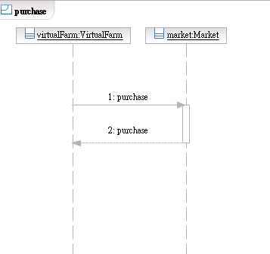

Exception Handling
Draw out any relevant information about how exception to the standard and expected logic is handled within the design. This is not meant to focus strictly on what language or distributed object exceptions are raised by any particular method within the component, but rather is intended to focus on how when exceptions to the main logic-paths do occur how they are handled.

Configuration
Describe how to initialize and manage the configuration of the system. For example, if the system uses xml-based configuration file, then describe how to modify the attributes in the file to bring system up and running.

Performance Assessment
What is the performance impact of this design on industry benchmarks? Note this in terms of the percentage change that you anticipate to the benchmark throughput.

Internationalization
Describe how this component will be enabled to support its use in other countries and in other languages and customs

Development Tools
Identify any development tool requirements that relate to the component. Include, for instance, tool pallets for visual builder tools, class libraries, etc. that may be needed to develop applications that exploit the component

Testing
Describe any conditions or environments that you think should be verified as part of a system test of this design. What kinds of situations would stress this design? What happens when features of the design are overloaded and what conditions might cause such an overload? How should the system behave in the event that critical servers, databases, or communication paths that this design depends upon are disrupted? Are there simple operational mistakes or tuning errors that may cause the design to behave poorly? Can the operations staff make dynamic tuning adjustments or other system changes that affect the behavior of this design? Do the features introduced in this design preclude simple migration of existing applications from previous versions of the product?

Release-to-Release Compatibility
Identify whether this design will affect portability or interoperation of applications hosted in a different version. If you break portability or interoperation you better have a very good reason for it. The general rule is interfaces can be deprecated, but must continue to be supported for three years after the interface has been marked as deprecated. Otherwise, we must maintain backwards compatibility.

Extensibility
Describe any extensibility features of this design. This should support any description you’ve provided for extensibility in the Programming Model

Platform Considerations
Describe the platform considerations, concerns and/or issues in the subsections below as they apply to internals and system design

Accessibility Considerations
Make offerings accessible to people who have disabilities.

Additional Design Elements
Include each additional design element that needs to be considered within this component. This section exists to cover anything that can not be covered in the sections that represent “common and standard” design elements of all components. They are aggregated under this sub-section only to provide some consistent structure to the overall design chapter.

SUPPORTING RATIONALE

Design Alternatives
Identify any design alternatives that were considered for the component and that may be relevant in future implementations of the component

Commercialization
Describe how and what commercial system facilities are used within the implementation of the component for delivering component function

Inter-Dependencies
Enumerate all technical and critical-path dependencies the component has on other components

Standards and Industry Trends
Identify which standards pertain to the component; and, where the component extends, deviates from, or integrates with the standard.

ISSUES
List any known issues that the design does not resolve or that have a bearing on future implementations of the component. This can also be used as a place holder for additional things that need to be factored in to the design, prior to that actually have been performed.

FUTURE ENHANCEMENTS
Describe any enhancements that should be considered in the future, but for which may have a bearing on the current design

